**Phase 3 : Data Modeling and Relationships**

**Objective:**

Create the data structure for the Leave Management System in Salesforce. This includes **custom objects, fields, relationships, page layouts, and views** for Employees, Managers, and HR.

**1. Create Custom Objects**

**Custom Object 1: Leave Request**

* Tracks each leave application.
* Steps:
  1. Setup → Quick Find → Object Manager → **Create → Custom Object**
  2. Label: Leave Request
  3. Plural Label: Leave Requests
  4. Record Name: Leave Request Number (Auto Number)
  5. Optional: Enable **Reports**, **Activities**, and **Allow in App**
  6. Save

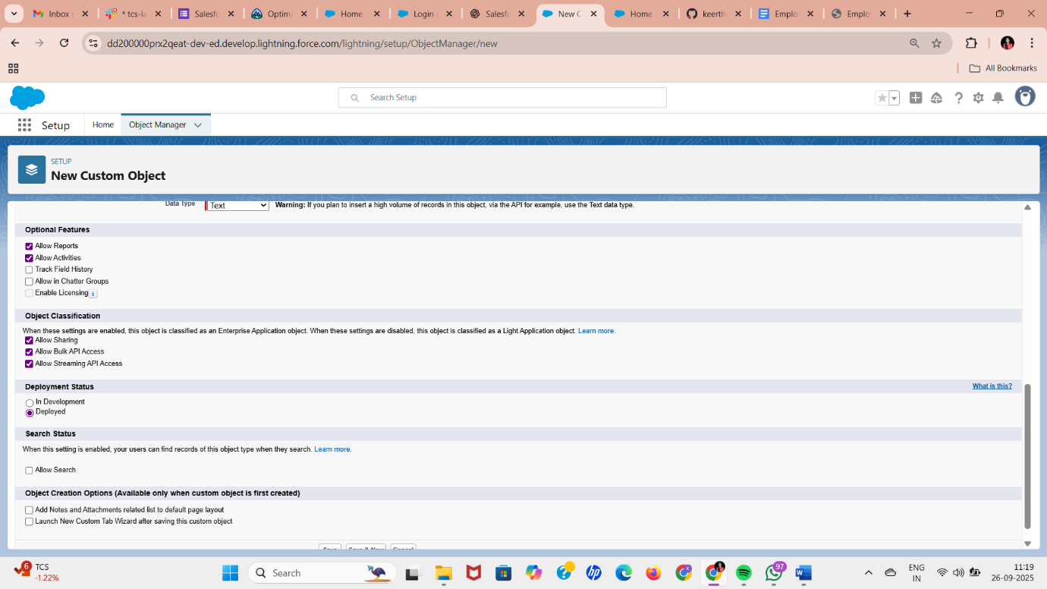

**Optional Custom Object 2: Leave Balance**

* Tracks total, used, and remaining leave per employee.
* Can also be implemented as fields on the User object if preferred.

**Add Fields to Leave Request**

* Setup → Object Manager → Leave Request → Fields & Relationships → **New**

| **Field Name** | **Type** | **Description / Values** |
| --- | --- | --- |
| Employee | Lookup (User) | Links leave request to employee |
| Leave Type | Picklist | Sick, Casual, Earned |
| Start Date | Date | Leave start date |
| End Date | Date | Leave end date |
| Total Days | Formula / Number | Calculated automatically or manually |
| Status | Picklist | Pending, Approved, Rejected |
| Reason | Long Text Area | Reason for leave |

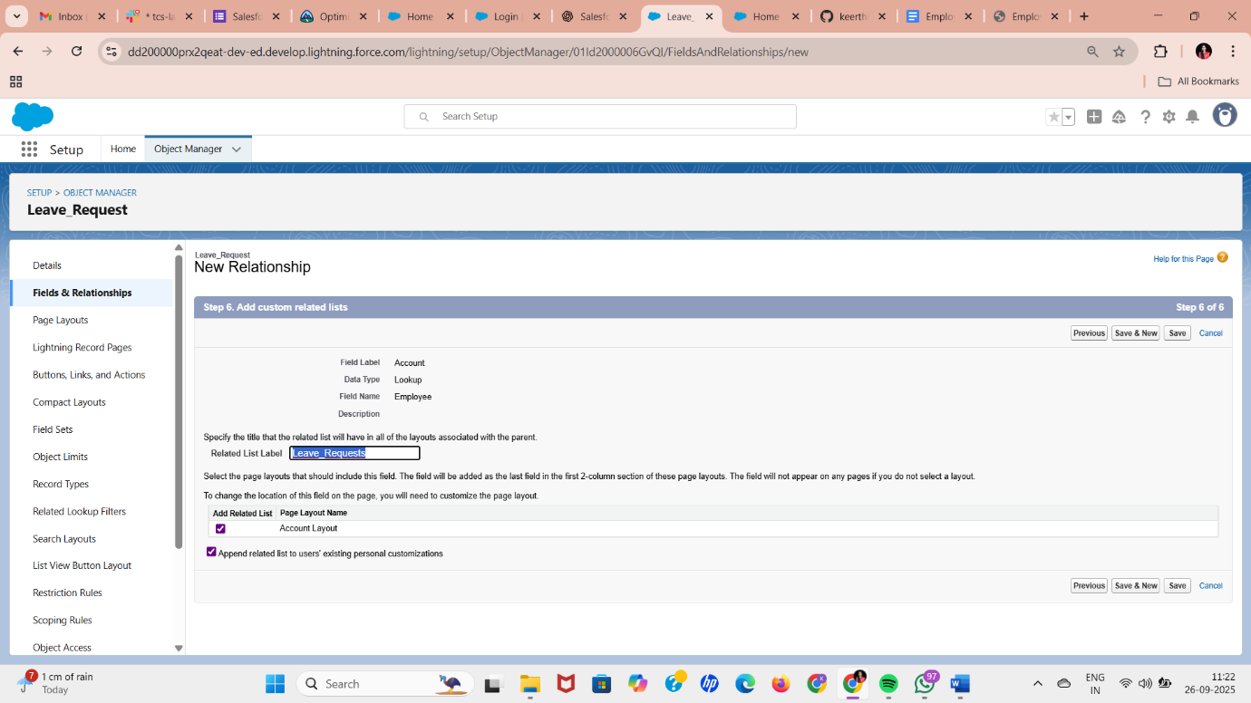

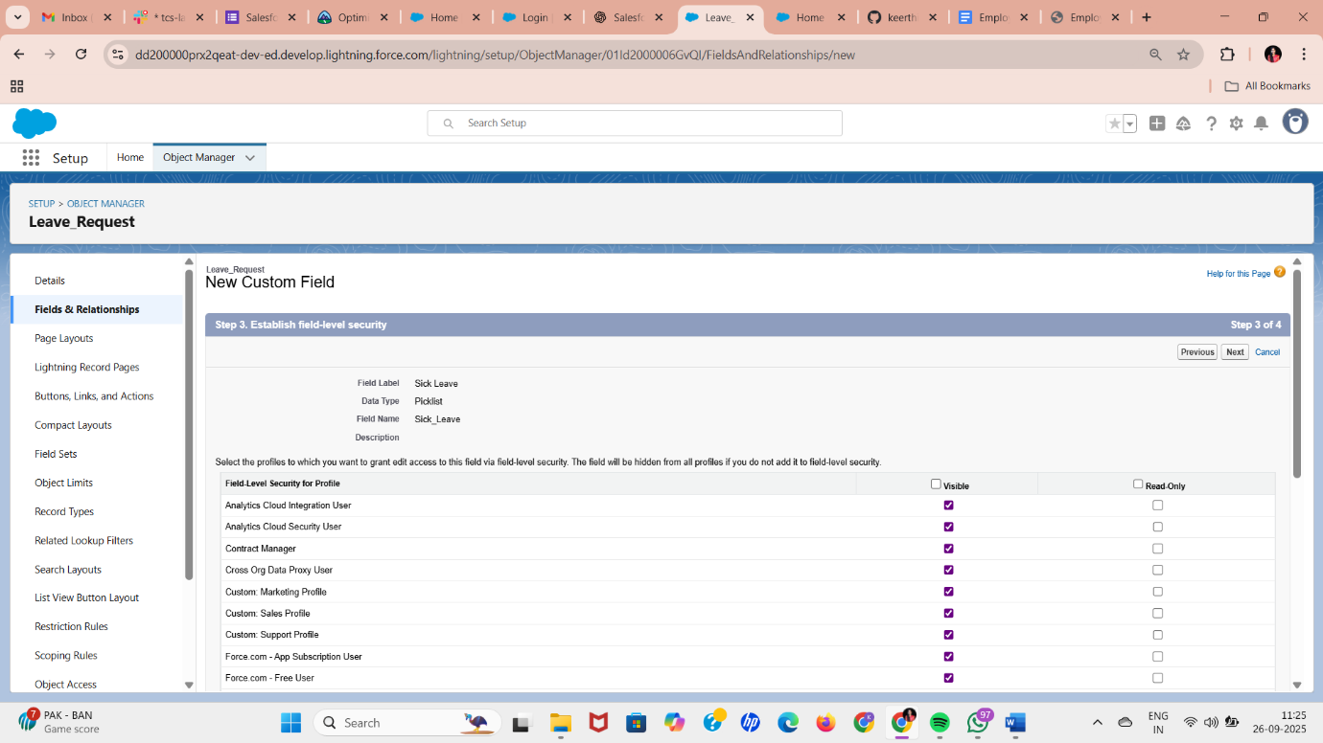

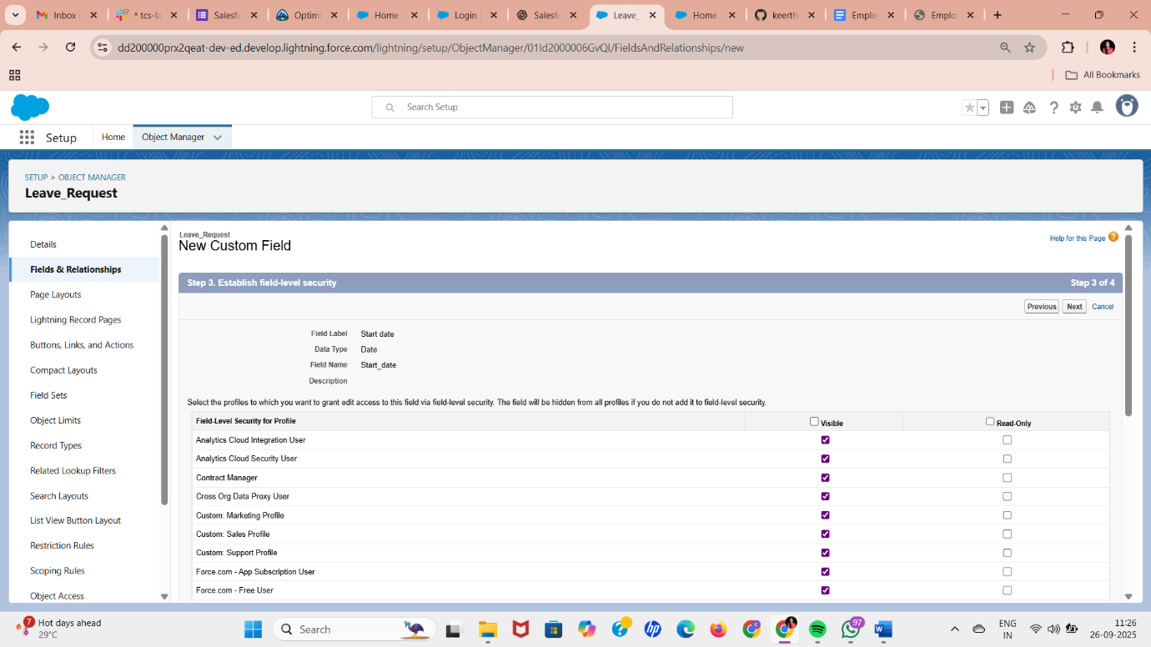

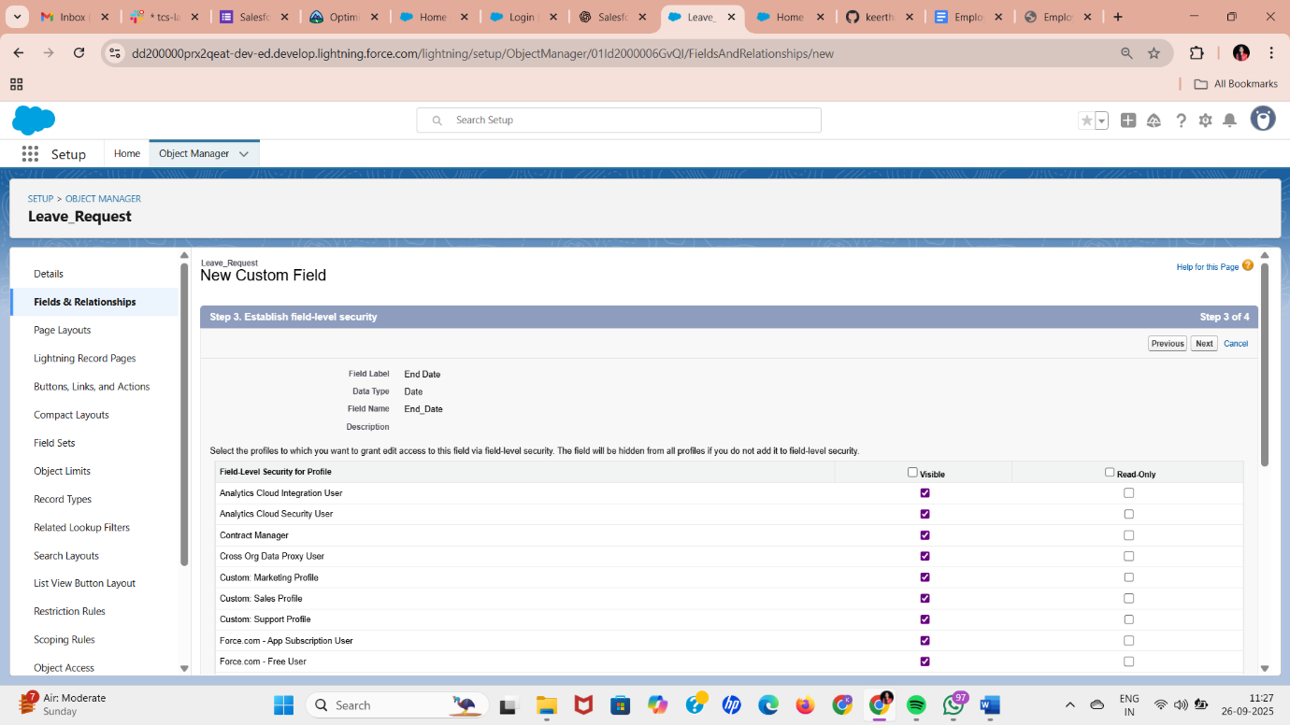

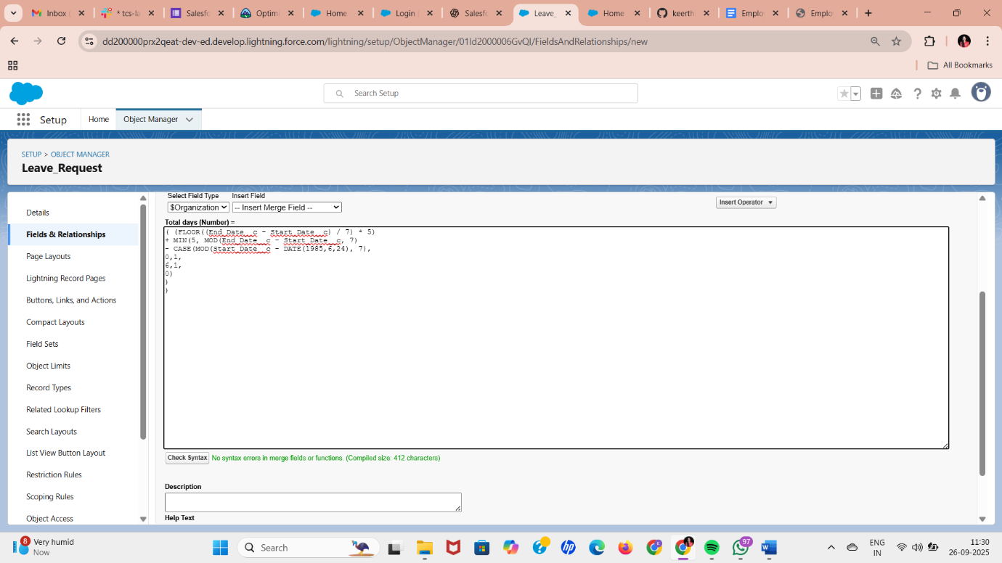

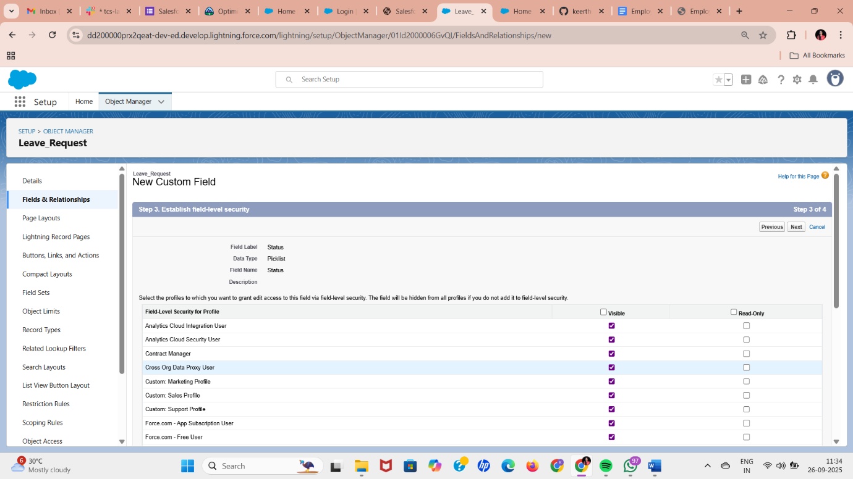

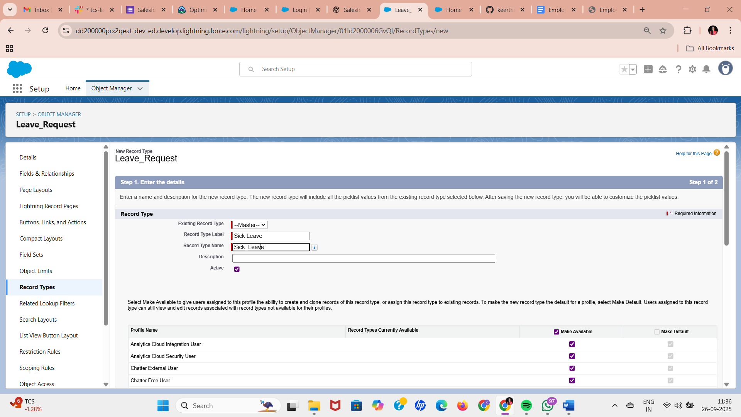

**3. Record Types (Optional for Different Leave Types)**

* Setup → Object Manager → Leave Request → Record Types → **New**
* Example: Sick Leave, Casual Leave, Earned Leave
* Assign to profiles (Employee, Manager, HR)
* Allows customizing **page layout per leave type**

**4. Page Layouts**

* Setup → Object Manager → Leave Request → Page Layouts → **New/Edit**
* Customize layout for each role:
  + **Employee Layout:** Fields for submitting leave request
  + **Manager Layout:** Includes approval/rejection fields
  + **HR Layout:** Full view of all leave information

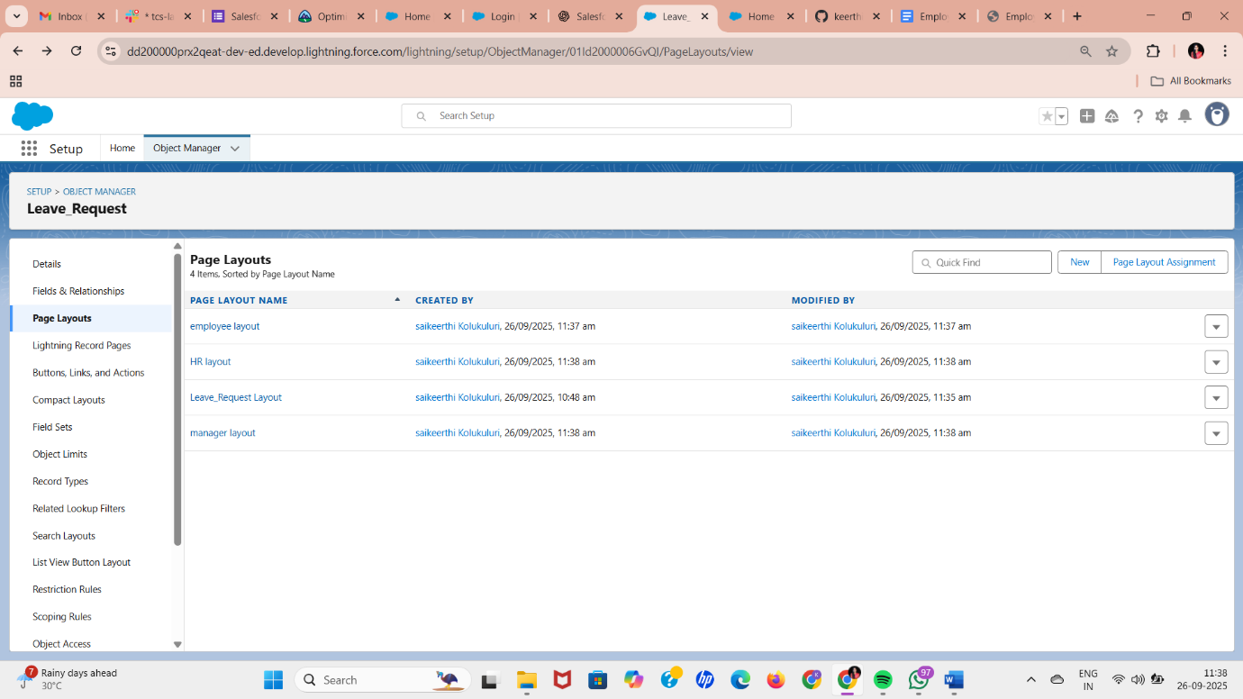

**5. Compact Layouts**

* Setup → Object Manager → Leave Request → Compact Layouts → **New**
* Fields for quick view (mobile or record highlights):
  + Leave Type
  + Start Date
  + End Date
  + Status

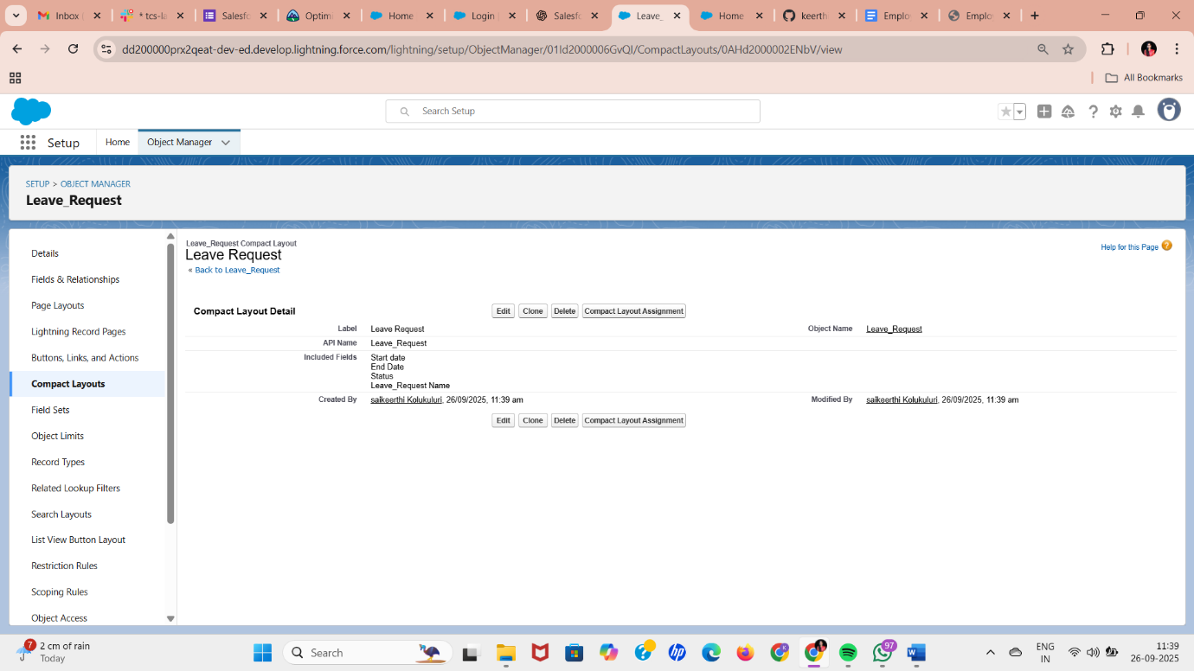

**6. Schema Builder**

* Setup → Quick Find → **Schema Builder**
* Drag **Leave Request** and **User** objects
* Visualize **relationships** (Lookup, Master-Detail)
* Helps you understand how objects connect

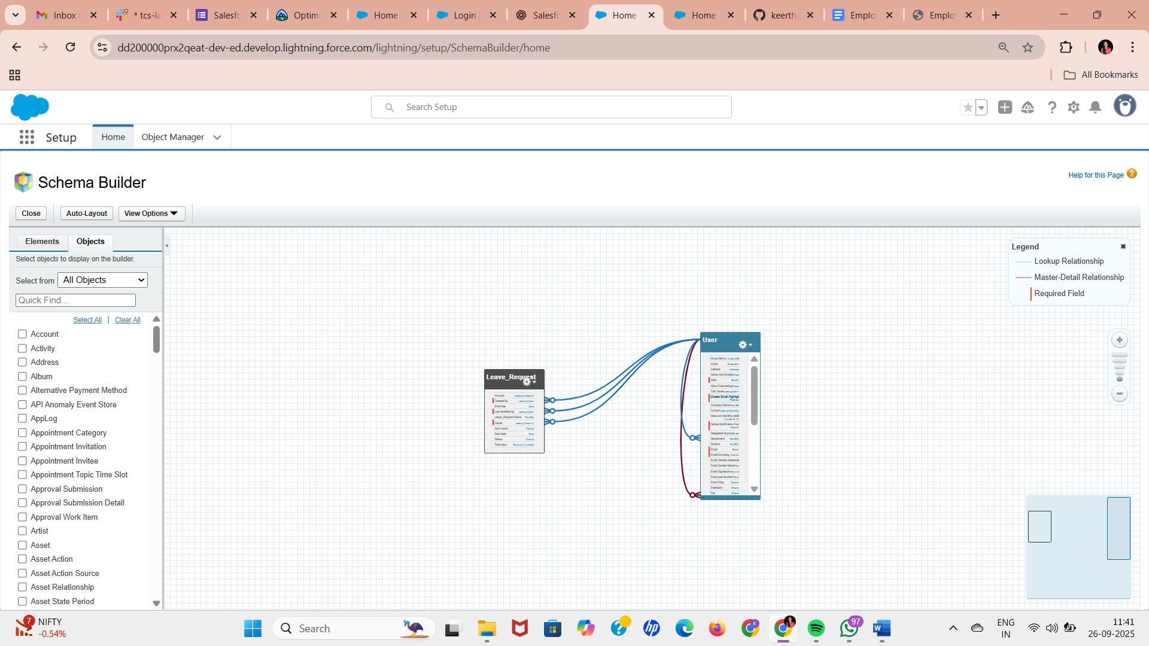

**7. Relationships**

**Recommended for this project:**

| **Relationship Type** | **Example / Use** |
| --- | --- |
| Lookup | Leave Request → Employee (User) |
| Master-Detail (Optional) | Leave Balance → Employee/User (for automatic roll-up summaries) |
| Hierarchical | User → Manager (built-in hierarchical field for approvals) |
|  |  |

**Implementation Notes:**

* Employees submit leave requests → linked to User via Lookup
* Manager sees team requests → uses **Role hierarchy + Sharing Rules**
* HR sees all requests → full access

**8. Junction Objects *(Optional / Advanced)***

* Only needed if you want **many-to-many relationships**, e.g., Employees ↔ Projects.
* Not required for basic leave management.

**9. External Objects *(Optional / Advanced)***

* Only needed if connecting to **external HR or payroll systems**.
* Can skip for Developer Org project.